
J. ADAMS & CO EXPANDS THE STRATA COLLECTION

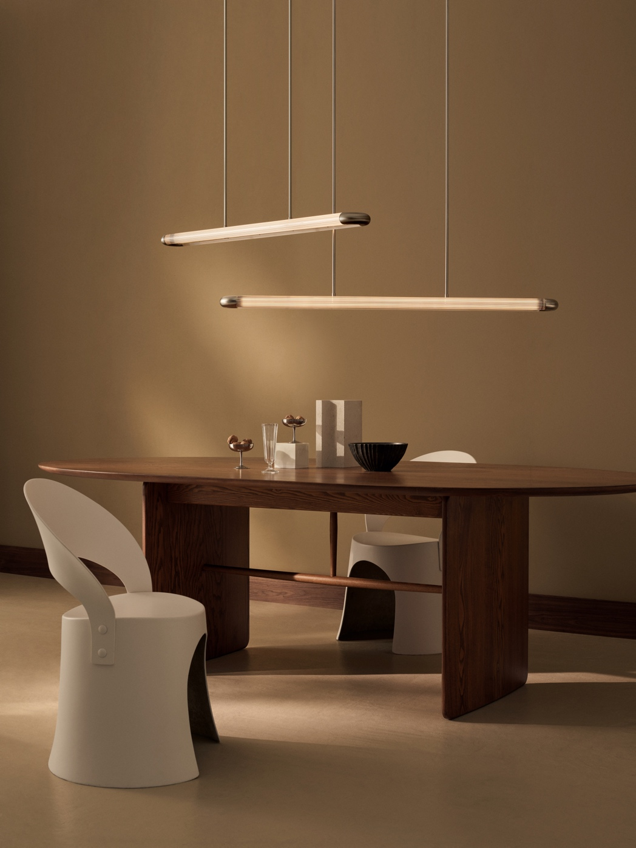

J. Adams & Co expands the Strata Collection with new pendant lengths and innovative designs.

Following the successful launch of the Strata Collection, J. Adams & Co is excited to unveil three new pendant options that build on the original series.

The Strata collection is a celebration of craftsmanship and ingenuity. Playing with materiality and the beauty of light refraction through reeded glass, Strata provides an enchanting, linear focal point. Each piece is expertly produced at the brand’s workshop using precision-cut glass and engineered solid brass.

This year, J. Adams & Co has taken the Strata Collection to new heights, pushing the boundaries of what’s possible in glass lighting. A major challenge was overcoming the inherent constraints of glass production; traditional methods are limited by the lengths of glass that can be manufactured, restricting the scope of the design.

As a result, the brand developed a machined brass component that elegantly joins two glass tubes, seamlessly merging them into a single, harmonious form. This innovative connector not only adds a distinctive edge to the Strata Pendant but also opens a world of possibilities for more dynamic and versatile configurations.

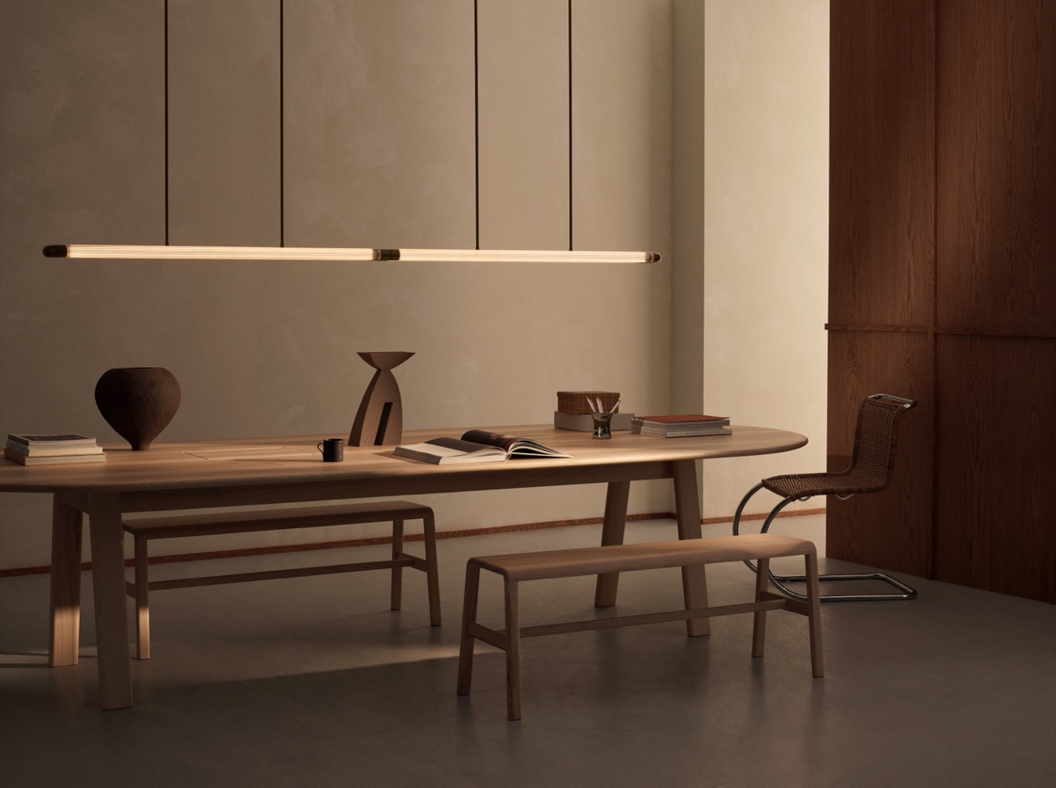

“We are always striving to push the boundaries of design while preserving the timeless qualities that define our brand. The new additions to the Strata Collection are a testament to our commitment to innovation and craftsmanship. By reimagining what can be done with glass, we’ve been able to create lighting solutions that are not only functional but also visually striking.” Will Earl, Design Director
The expanded Strata Pendant range now includes multiple lengths, allowing designers to play with scale, balance, and proportion in their lighting arrangements.

The 1200mm length, slightly shorter than the original 1600mm pendant, works beautifully over smaller kitchen islands and dining tables. For round or oval tables, multiple pendants can be overlapped in a modern, dynamic composition.

The 2400mm length is perfect for making a bold statement in spaces with high ceilings, such as entrance halls or open foyers. This length is also ideal for illuminating desks in commercial offices or for providing striking overhead lighting above kitchen islands and bars.

The 3200mm length, doubling the original span, redefines scale with its impressive presence; perfect for large open spaces, over larger dining tables or meeting tables, where its elongated form adds drama and elegance.

For high resolution imagery, videos, quotes and product loans, please contact press@jadamsandco.com

Notes to Editors:
J. Adams & Co is a British lighting manufacturer that specialises in elegant luminaires of unparalleled quality. Handmade in the UK, their Birmingham factory has over half a century of manufacturing and metalworking expertise. The brand seamlessly melds traditional techniques with a nuanced, modern sensibility, focusing on craftsmanship and longevity. The result: refined and contemporary lighting that is built to last.

